JEREMY PERSAUD N01338636

GAGANDEEP SAINI N01305833

NATHANIEL VARAS-HEDMAN N01112536

SUNSHINE BOYS

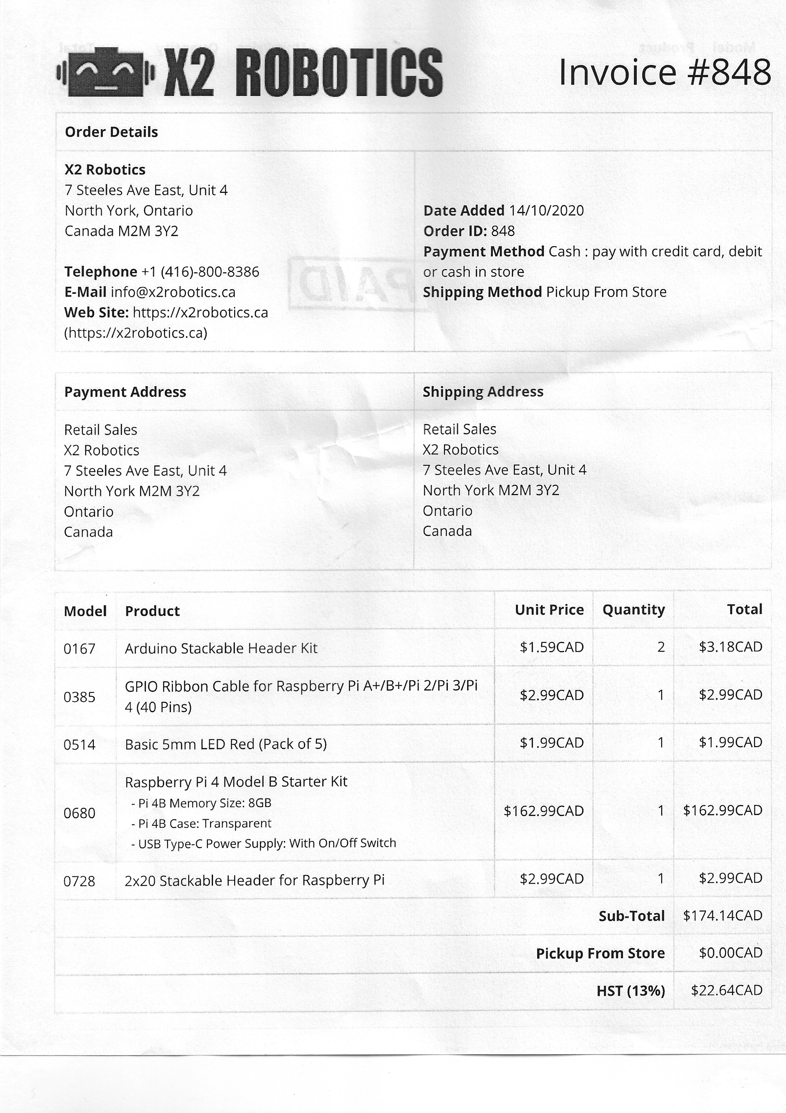

Jeremy Persaud N01338636

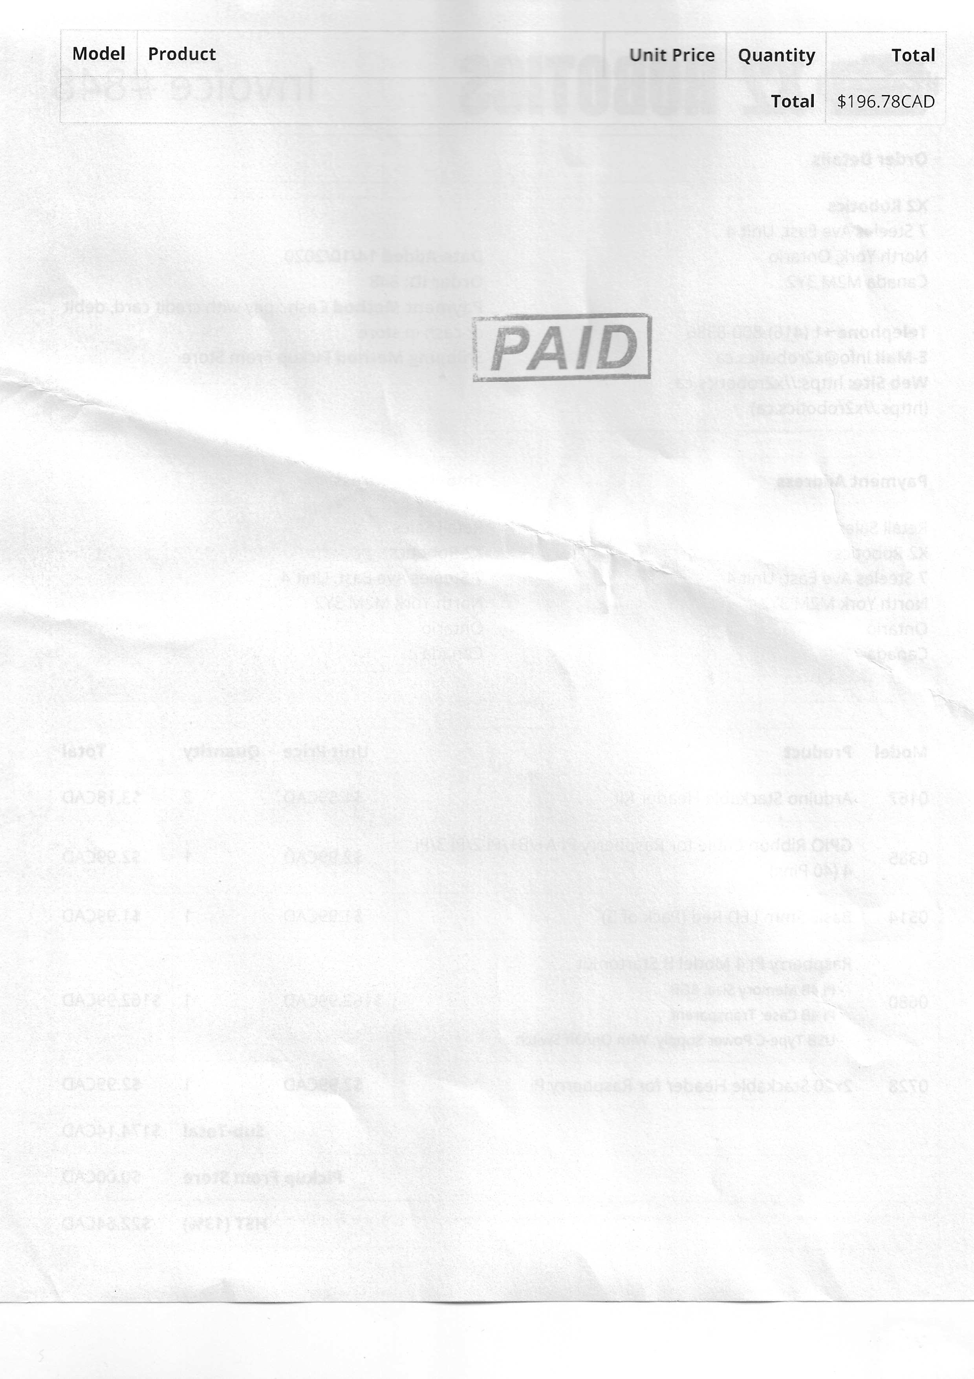

Jeremy Persaud N01338636

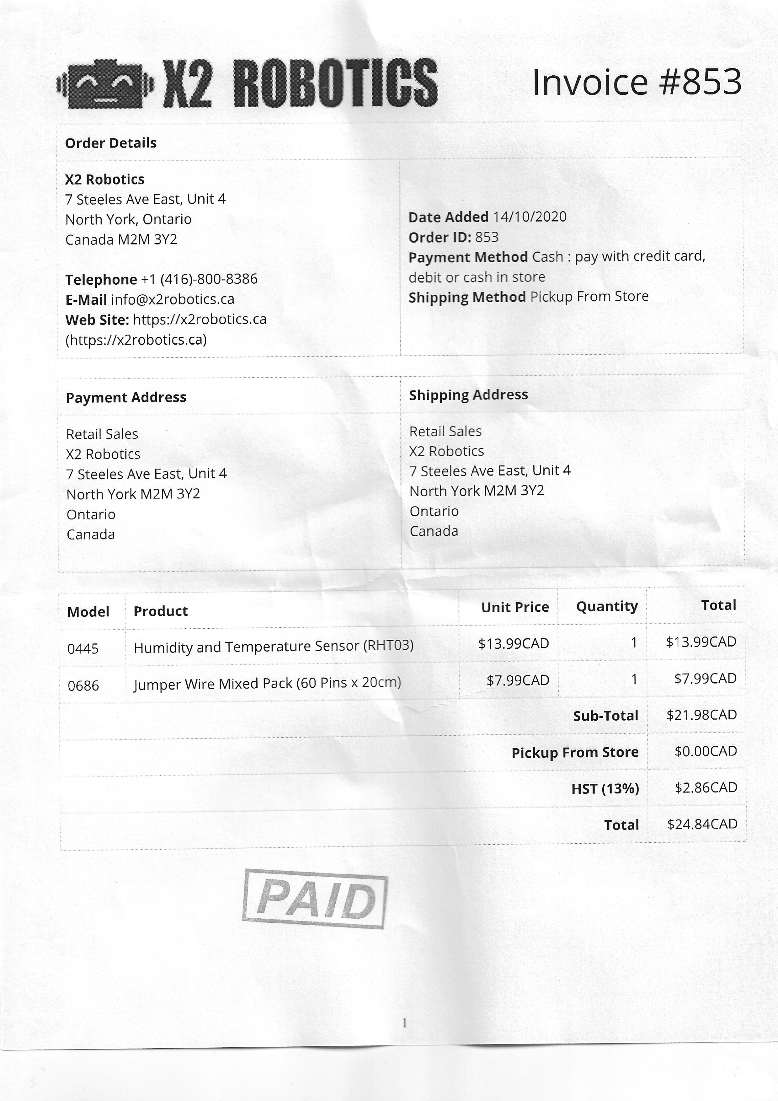

Jeremy Persaud N01338636

Jeremy Persaud N01338636

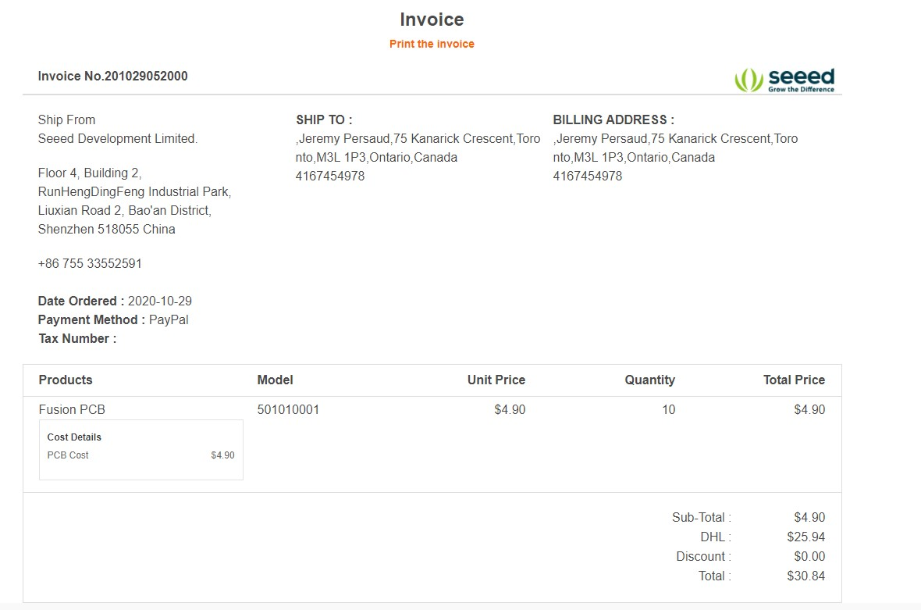

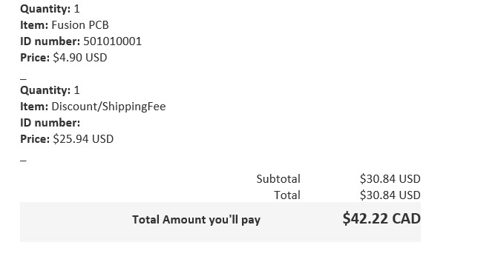

Jeremy Persaud N01338636

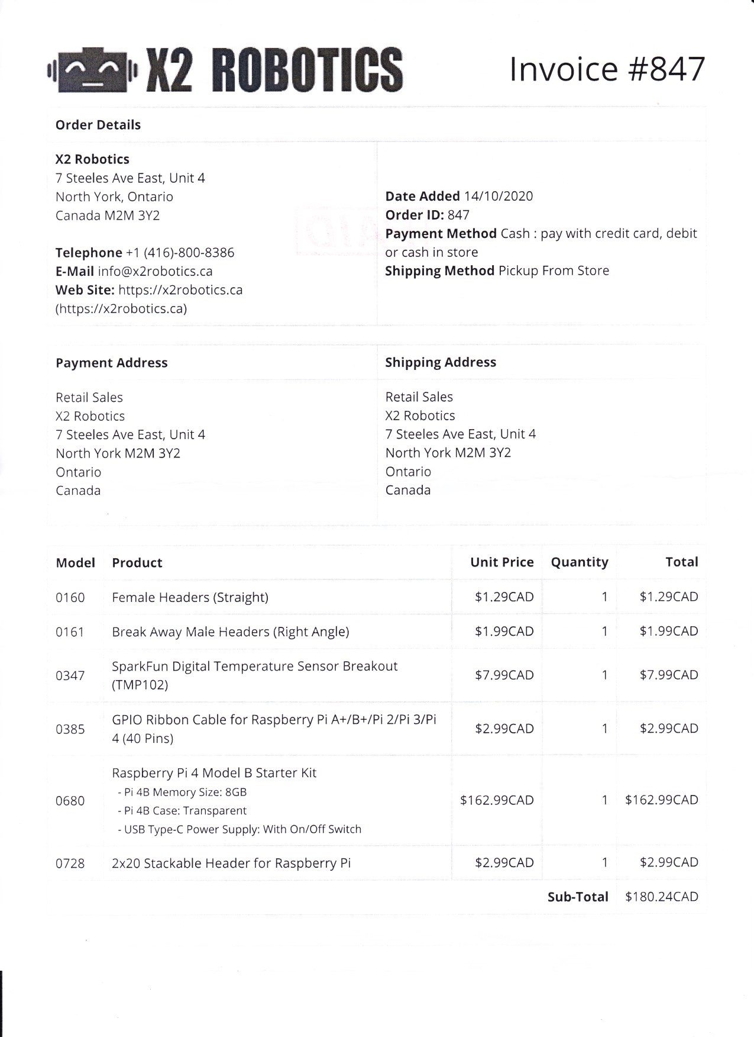

Gagandeep Saini N01305833

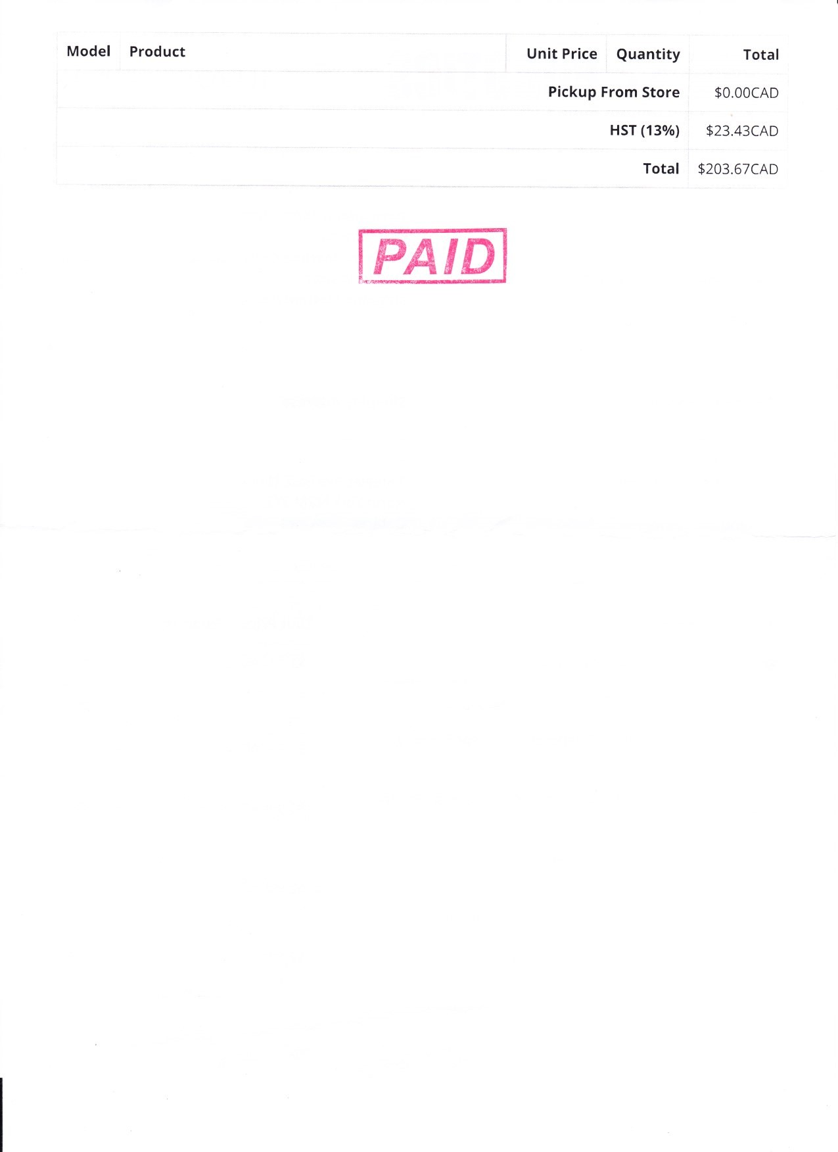

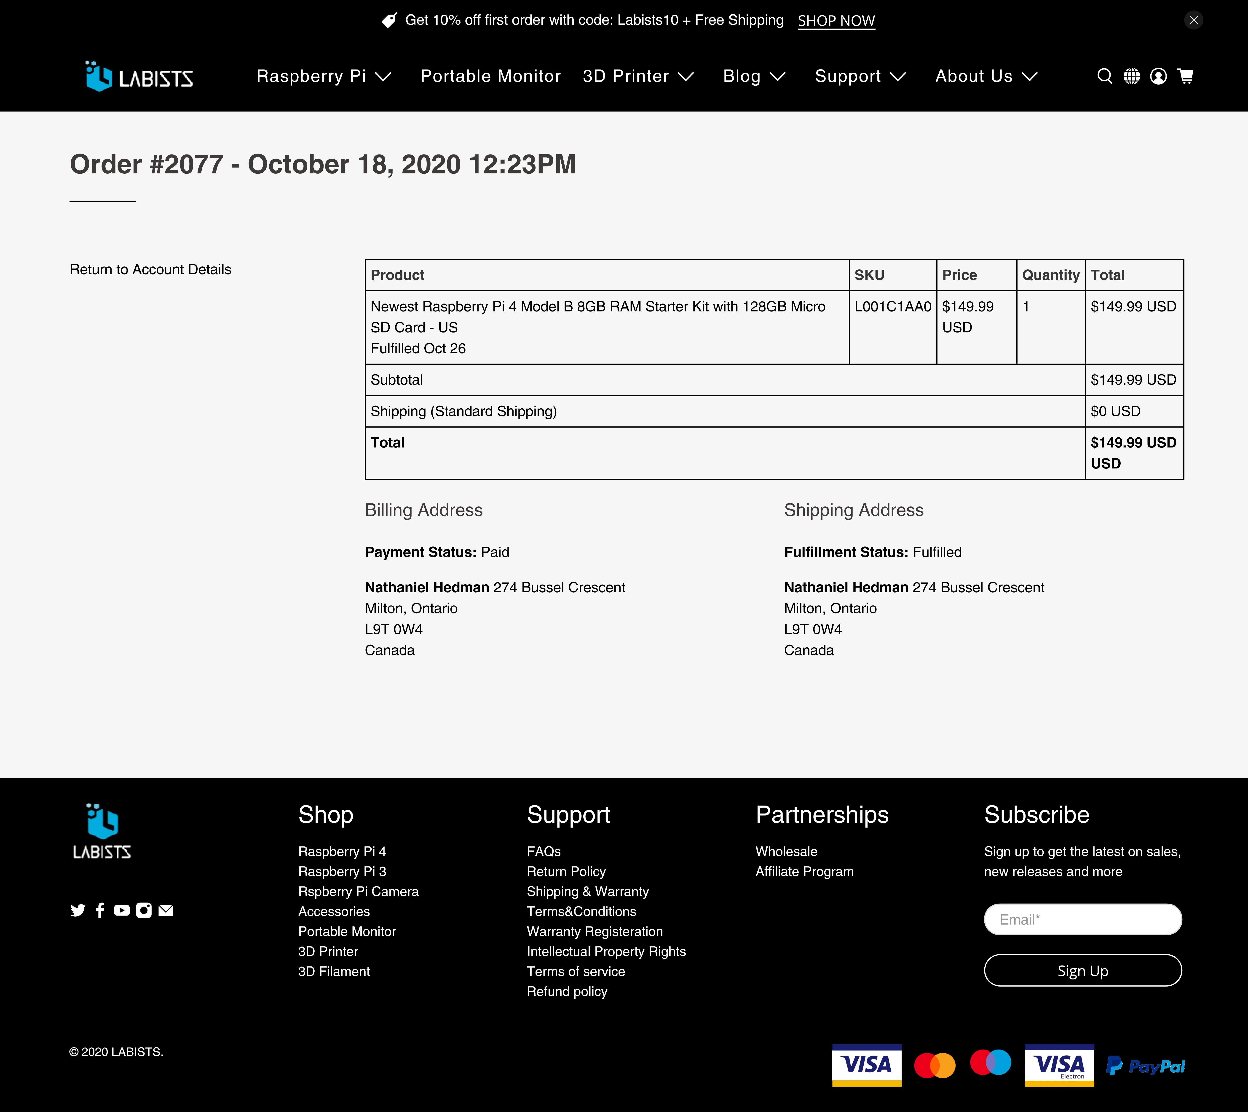

NATHANIEL VARAS-HEDMAN N01112536

|  |  |
| --- | --- |
| **USA** | **Completed Salesorder CAD $** |

**701 Brooks Ave South, www.digikey.ca PO Box 677 Orders 1-800-344-4539**

# Archive Invoice # 76568903

**Thief River Falls, MN 56701-0677 Fax 218-681-3380**

NATHANIEL VARAS-HEDMAN N01112536

|  |  |  |  |  |  |
| --- | --- | --- | --- | --- | --- |
| **Bill**  **To:** | |  | | --- | | NATHANIEL HEDMAN  274 BUSSEL CRESCENT MILTON ON L9T 0W4  CANADA | | **Ship**  **To:** | |  | | --- | | NATHANIEL HEDMAN  274 BUSSEL CRESCENT MILTON ON L9T 0W4  CANADA | |

**Salesorder / Packlist:** 66332875 / PL1

**Customer:** 13171223

**Payment Terms:** PAYPAL

**Shipping Method:** XF1D

**Tracking #:** 929589362822

|  |  |  |  |  |  |  |  |  |  |  |  |  |  |  |  |  |
| --- | --- | --- | --- | --- | --- | --- | --- | --- | --- | --- | --- | --- | --- | --- | --- | --- |
| **Buye**  **r:** | |  | | --- | | NATHANIEL HEDMAN 274 BUSSEL CRES  MILTON ON L9T0W4  CANADA | | | | | | | | **Ship**  **From**  **:** | |  | | --- | | DIGI-KEY ELECTRONICS  701 BROOKS AVE. SOUTH P.O. BOX 677  THIEF RIVER FALLS MN 56701-0677 | | | | | | |
| **Order Source:** | | | | | **Order Date:** | | | **Invoice Date:** | | | **Ship Date:** | | **Document Date:** | |
| INTERNET | | | | | 17-Oct-2020 | | | 18-Oct-2020 | | | 19-Oct-2020 | | 18-Oct-2020/AUTO | |
| **Line**  **Item** | | | **Ordered** | **Cancelled** | | **Shipped** |  | | | | | **Item Number/ Description** | | | | | **Unit Price**  **CAD $** | **Amount**  **CAD $** | | |
| 1 | | | 1 | 0 | | 1 | **PART:** 1528-4494-ND  **MFG :** Adafruit Industries LLC / 4494 | | | | | **DESC:** BAROMETRIC PRESSURE / ALTITITUDE | | | | | 10.04000 | 10.04 T | | |
|  | | |  |  | |  | **COO :** UNITED STATES  ROHS NONC | | | | | **ECCN:** EAR99 **HTSUS:** 8473.30.1180 | | | | |  |  | | |
| Sales Amount  Shipping charges applied ** Charges subtotal ** | | | | | 10.04  8.00  18.04 |
| HST on taxable amount: 10.04 Tax Rate: 13.00 | | | | | 1.31 |
| Total charged to Paypal | | | | | 19.35 |
| N_varashedman@hotmail.com | | | | | CAD $ |

Incoterm 2020: DDP MILTON, ON, CANADA

T indicates taxable amounts

* NO EEI 30.36
* These items are controlled by the U.S. Government and authorized for export only to the country of ultimate destination for use by the ultimate consignee or end-user(s) herein identified. They may not be resold, transferred, or otherwise disposed of, to any other country or to any person other than the authorized ultimate consignee or enduser(s), either in their original form or after being incorporated into other items, without first obtaining approval from the U.S. Government or as otherwise authorized by U.S. law and regulations.

|  |  |  |  |  |  |  |  |
| --- | --- | --- | --- | --- | --- | --- | --- |
| **Box** | **Ship Method** | **Tracking** | **Weight** | **Line Item** |  | **Part** | **Quantity** |
| 1 | XIPR | 929589362822 | 0.14 kgs / 5 oz | 1 | 1528-4494-ND |  | 1 |

General -WEB ORDER ID: 313688099

CUSTOMER INDICATED THAT PRODUCT WILL NOT BE EXPORTED OUTSIDE OF CANADA. A0FX

DIGI-KEY NRI #: 895173490 DIGI-KEY GST/HST#: 895173490RT

## Page 1 of 2

**701 Brooks Ave South,**

**PO Box 677**

## Thief River Falls, MN 56701-0677

**USA**

CERTIFICATE OF COMPLIANCE:

## www.digikey.ca

|  |  |
| --- | --- |
| **Orders 1-800-344-4539**  **Fax 218-681-3380** | **Archive Invoice # 76568903**  **Completed Salesorder CAD $** |

The Digi-Key or supplier direct ship products included in the above shipment were purchased from the original manufacturer or through the manufacturer’s authorized distribution. The original manufacturer warrants and certifies that the products they produce meet their specifications. Test reports (chemical, physical, electrical, etc.) supporting their certification are on file (either at Digi-Key, the supplier or in the plant of the manufacturer) and will be made available upon request. This document is evidence of Conformity that this shipment meets the requirements of Digi-Key’s Quality Management System and/or Purchase Order requirements agreed on between the customer and Digi-Key. This certification is valid only to the original customer and is not transferable.



Marie Sander, Manager, Customer Service

Claims for pricing errors, shortages, and defective product must be reported within 30 days of invoice date. ***Contact Customer Service at 1-800-858-3616***

**All transactions with Digi-Key Electronics, including its subsidiaries and/or affiliates, are subject to Digi-Key's Terms of Use and Conditions of Order, available at www.digikey.ca.**

NATHANIEL VARAS-HEDMAN N01112536

DIGI-KEY NRI #: 895173490 DIGI-KEY GST/HST#: 895173490RT

**Page 2 of 2**

NATHANIEL VARAS-HEDMAN N01112536

**SparkFun Invoice**

NATHANIEL VARAS-HEDMAN N01112536

# #6333804

6333 Dry Creek Parkway • Niwot, CO 80503

1-303-284-0979

Ordered: 2020-11-04 03:41:12 pm

|  |  |  |  |
| --- | --- | --- | --- |
| **Billing**  Nathaniel Hedman  274 Bussel Crescent  Milton, ON L9T0W4  Canada |  | **Delivery**  Nathaniel Hedman  274 Bussel Crescent Milton, ON L9T0W4  Canada 6478313337  n_varashedman@hotmail.com | |
| **Shipping Method: FedEx International Mail Service**  **Payment Method:** PayPal Express Checkout  **Order Status:** New Order |  |  |  |
| **SKU Product Name** | **Qty** | **Price** | **Total** |
| COM-09592 LED - Basic Green 5mm | 4 | $0.35 | $1.40 |
| PRT-16763 Extended GPIO Female Header - 2x20 Pin (16mm/7.30mm) | 1 | $1.95 | $1.95 |

|  |  |
| --- | --- |
| Subtotal | $3.35 |
| Shipping/Handling | $3.37 |
| Grand Total | $6.72 |
| **Transactions:** |  |
| Nov-04 Paypal  n_varashedman@hotmail.com | $6.72 |

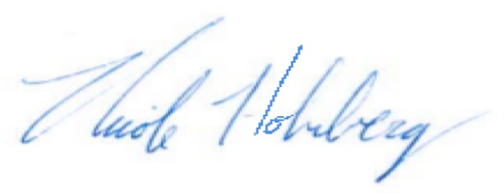**SUPPLIER'S CERTIFICATION OF COMPLIANCE**

It is hereby certified that the product(s) provided in this shipment conform to the requirements and the manufacturer's part number identified in the customer's purchase order and these parts have been received, stored and shipped by SparkFun Electronics.

## Order Balance: $0.00

Nicole Holmberg, Sales Operations Manager

These commodities, technology or software were exported from the United States in accordance with the Export Administration Regulations.

Diversion contrary to U.S. law is prohibited.

Please direct any questions or concerns to support@sparkfun.com or (303) 284-0979.

**Did you know SparkFun's packaging is recyclable?**

Both our red boxes and brown paper packaging can be recycled in most areas. Thanks for doing your part!

Page 1 of 1

NATHANIEL VARAS-HEDMAN N01112536